# Assignment -3 Bucket And Watson assistant

|  |  |
| --- | --- |
| Assignment Date | 14 November 2022 |
| Student Name | Mohammed Sinan K C |
| Student Roll Number | **721919104034** |
| Maximum Marks | 2 Marks |

**Questions:**

# Create a Bucket in IBM object storage.

1. **Upload an 5 images to ibm object storage and make it public. write html code to displaying all the 5 images.**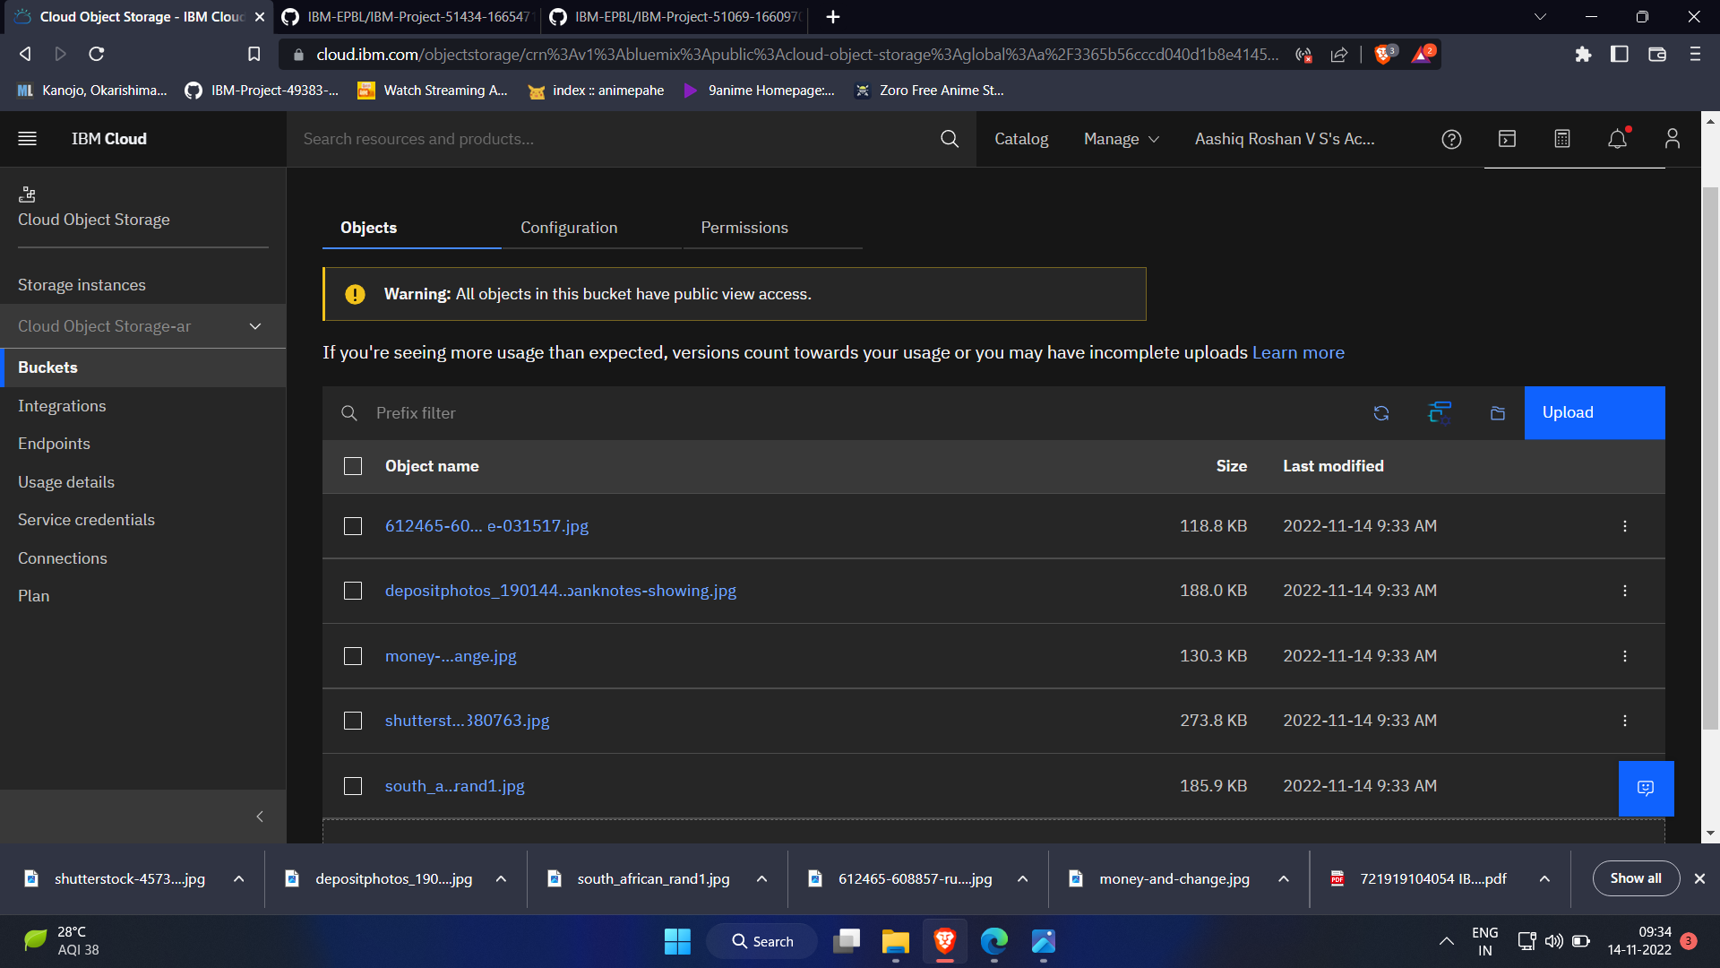

# Index.html

<!DOCTYPE *html*>

<html *lang*="en">

<head>

<meta *charset*="UTF-8">

<meta *http-equiv*="X-UA-Compatible" *content*="IE=edge">

<meta *name*="viewport" *content*="width=device-width, initial-scale=1.0">

<link rel="stylesheet" href="styles.css">

  <title>Personal Expense Tracker </title>

<style> body {

background-color: aqua; display: flex; align-items: center; justify-content:

center; flex-direction: column;

}

 img {

height: 240px;

border-radius: 10px;

margin: 10px;

 }

 </style>

</head>

<body>

 <h1>Welcome To Expense Tracker</h1>

 <div>

 <img src="https://ibmclouddemo-ar.s3.ap.cloud-object-storage.appdomain.cloud/612465-608857-rupee-031517.jpg"

alt="money" srcset="">

 <img src="https://ibmclouddemo-ar.s3.ap.cloud-object-storage.appdomain.cloud/depositphotos_190144094-stock-photo-new-saudi-riyal-banknotes-showing.jpg"

alt="money" srcset="">

 <img src="https://ibmclouddemo-ar.s3.ap.cloud-object-storage.appdomain.cloud/money-and-change.jpg"

alt="money" srcset="">

 <img src="https://ibmclouddemo-ar.s3.ap.cloud-object-storage.appdomain.cloud/shutterstock-457380763.jpg"

alt="money" srcset="">

 <img src="https://ibmclouddemo-ar.s3.ap.cloud-object-storage.appdomain.cloud/south_african_rand1.jpg"

alt="money" srcset="">

 </div>

</body>

</html>

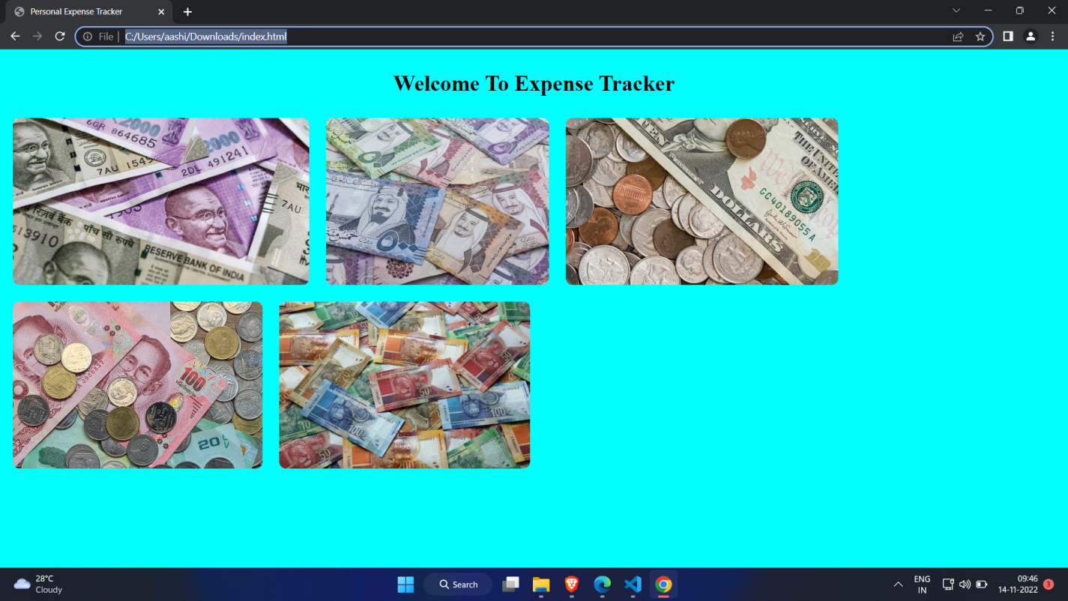

# Upload a css page to the object storage and use the same page in your HTML code.

<!DOCTYPE html>

<html lang="en">

<head>

 <meta charset="UTF-8">

 <meta http-equiv="X-UA-Compatible" content="IE=edge">

 <meta name="viewport" content="width=device-width, initial-scale=1.0">

 <link rel="stylesheet" href="styles.css">

 <title>Personal Expense Tracker </title>

 <style>

body {

 background-color: aqua;

display: flex; align-items:

center; justify-content:

center; flex-direction:

column; }

 img {

height: 240px;

border-radius: 10px;

margin: 10px;

 }

 </style>

</head>

<body>

 <h1>Welcome To Expense Tracker</h1>

 <div>

 <img src="https://ibmclouddemo-ar.s3.ap.cloud-object-storage.appdomain.cloud/612465-608857-rupee-031517.jpg"

alt="money" srcset="">

 <img src="https://ibmclouddemo-ar.s3.ap.cloud-object-storage.appdomain.cloud/depositphotos_190144094-stock-photo-new-saudi-riyal-banknotes-showing.jpg"

alt="money" srcset="">

 <img src="https://ibmclouddemo-ar.s3.ap.cloud-object-storage.appdomain.cloud/money-and-change.jpg"

alt="money" srcset="">

 <img src="https://ibmclouddemo-ar.s3.ap.cloud-object-storage.appdomain.cloud/shutterstock-457380763.jpg"

alt="money" srcset="">

 <img src="https://ibmclouddemo-ar.s3.ap.cloud-object-storage.appdomain.cloud/south_african_rand1.jpg"

alt="money" srcset="">

 </div>

</body>

</html>

alt="money" srcset="">

 <img src="https://ibmclouddemo-ar.s3.ap.cloud-object-storage.appdomain.cloud/depositphotos_190144094-stock-photo-new-saudi-riyal-banknotes-showing.jpg"

alt="money" srcset="">

 <img src="https://ibmclouddemo-ar.s3.ap.cloud-object-storage.appdomain.cloud/money-and-change.jpg"

alt="money" srcset="">

 <img src="https://ibmclouddemo-ar.s3.ap.cloud-object-storage.appdomain.cloud/shutterstock-457380763.jpg"

alt="money" srcset="">

 <img src="https://ibmclouddemo-ar.s3.ap.cloud-object-storage.appdomain.cloud/south_african_rand1.jpg"

alt="money" srcset="">

 </div>

</body>

</html>

**Output:-**

# Design a chatbot using IBM Watson assistant for hospital. Ex: User comes with query to know the branches for that hospital in your city. Submit the web URL of that chat bot as a assignment.

**Url :-** [**chatbot link**](https://web-chat.global.assistant.watson.appdomain.cloud/preview.html?backgroundImageURL=https%3A%2F%2Feu-gb.assistant.watson.cloud.ibm.com%2Fpublic%2Fimages%2Fupx-2187bdc6-3463-4336-a0e5-105ac4d979db%3A%3A31897cd3-e620-4527-80d8-c93d7c618899&integrationID=fd3649a9-27f7-43a9-96c0-5ca4d5bbf885&region=eu-gb&serviceInstanceID=2187bdc6-3463-4336-a0e5-105ac4d979db) **<- click Image-**

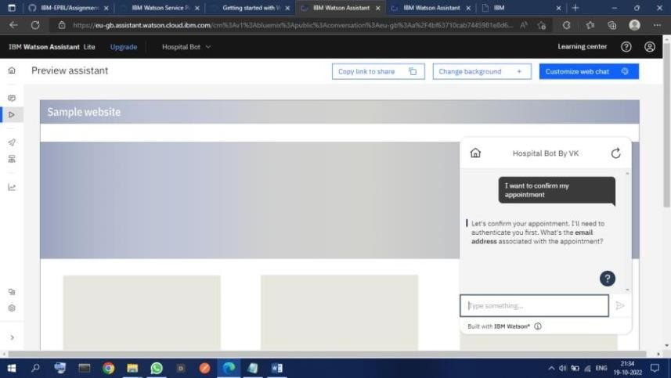

# 5 .Create Watson assistant service with 10 steps and use 3 conditions in it. Load that script in HTML page



